**HOME**

Fashion is a highly visual industry, which explains why Instagram is the social network of choice for lovers of style. But there is far more fashion content online than what people share on social media. It has always been a strong niche for blogging.

There are many quality fashion blogs, which unsurprisingly feature high-quality photographs of the latest fashion innovations.  Most fashion blogs are full of inspiration for those mornings you open your wardrobe door with your mind in a blank. They make an ideal place to begin your online research into what’s hot this year before you head off to purchase your own outfits. They can also provide you with ideas about what you can mix and match to create that perfect look.

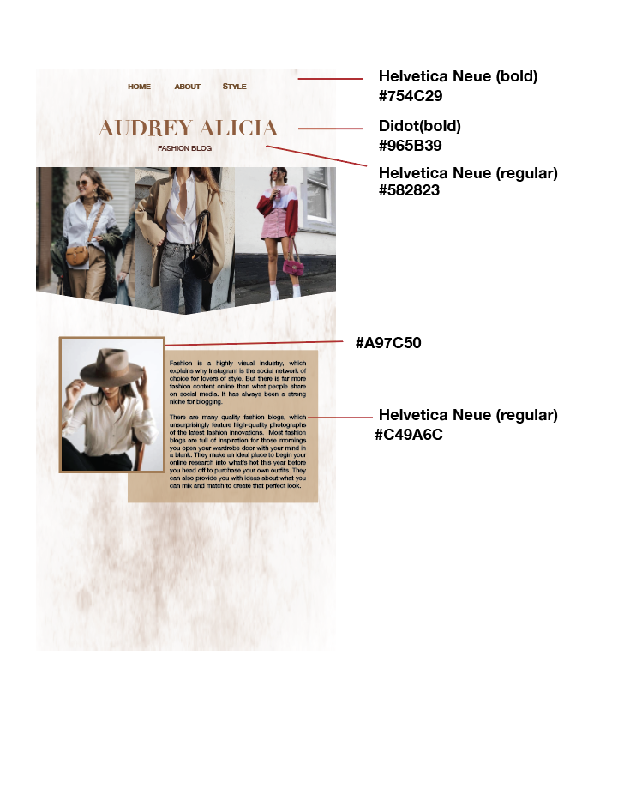

Helvetica Neue (bold)

#754C29

Didot (bold)

#965B39

Helvetica Neue (reguler)

#582823

#A97C50

Helvetica Neue (reguler)

# C49A6C

**ABOUT 1**

**Just a Bit About Fashion**

"Fashion, to me, represents life. When I wear something more...creative, more interesting, stronger, complicated alive, the most engaged with the world. Changing my wardrobe is the quickest route to feeling like everything is new again, that anything is possible. So the purpose of fashion is to make you feel alive and present. I hate it when people get too philosophical about fashion, but this really is the truth!" that makes me feel that's when I feel the most

**And how to steal their style**

Searching for online style inspiration, it’s easy to fall down the black hole of Insta-hell. When you finally look up from your phone, you realise you’ve spent two whole days scrolling through feeds – and you’re still in your dressing gown, with no idea what to wear (we’ve all been there). Which sort of defeats the point.

Well never fear, we’ve done the hard search for you. From our favourite UK influencers to the best missives from Milan and the coolest New Yorkers, read on for our definitive guide to the best fashion blogs (and more importantly, where to shop their looks).

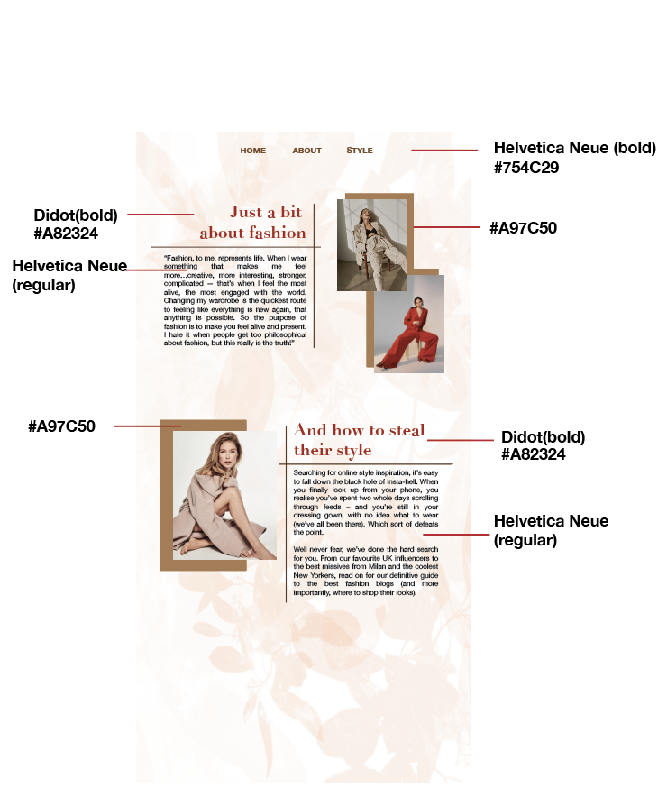

Helvetica Neue(bold)

#754C29

Didot (bold)

#A82324

#A97C50

Helvetica Neue(reguler)

#A97C50

Didot (bold)

#A82324

Helvetica Neue (reguler)

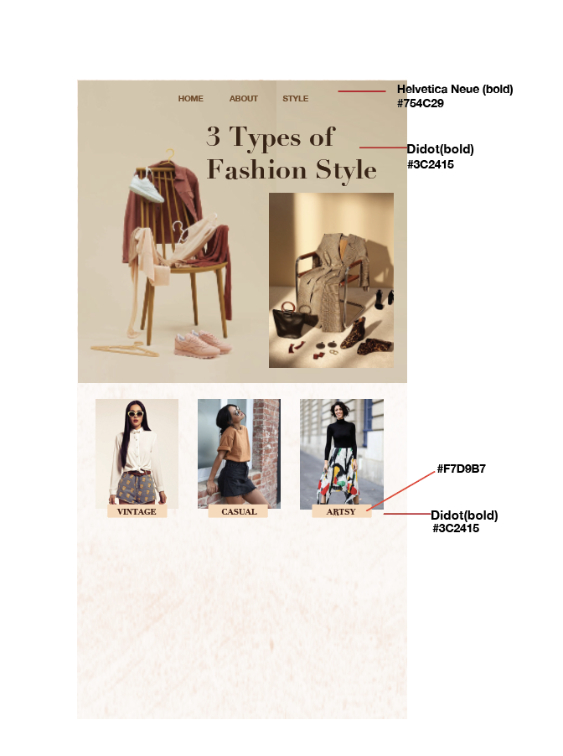

Helvetica Neue(bold)

#764C29

Didot (bold)

#3C2415

#F7D9B7

Didot (bold)

#3C2415

FashioFashion, to me, represents life. When I wear something that makes me feel more…creative, more interesting, stronger, complicated — that’s when I feel the most alive, the most engaged with the world. Changing my wardrobe is the quickest route to feeling like everything is new again, that anything is possible. So the purpose of fashion is to make you feel alive and present. I hate it when people get too philosophical about fashion, but this really is the truth!

n, to me, represents life. When I wear something that makes me feel more…creative, more interesting, stronger, complicated — that’s when I feel the most alive, the most engaged with the world. Changing my wardrobe is the quickest route to feeling like everything is new again, that anything is possible. So the purpose of fashion is to make you feel alive and present. I hate it when people get too philosophical about fashion, but this really is the truth!

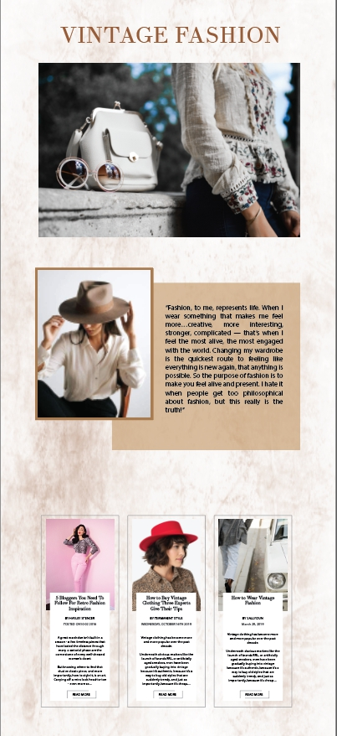

Typeface:Helvetica neue regular.

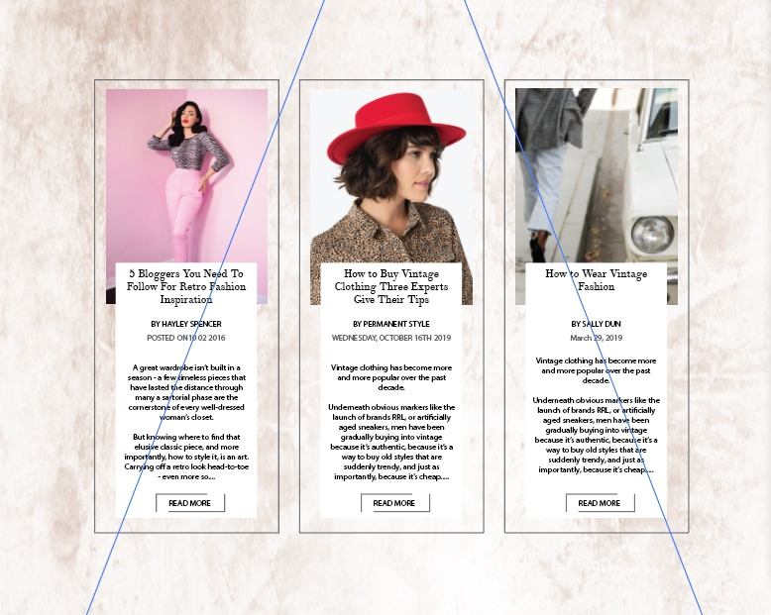

1.

5 Blogger You Need To Follow For Retro Fashion Inspiration (Theano Didot)

BY HAYLEY SPENCER

POSTED ON 10 02 2016 (HELVETICA)

A great wardrobe isn’t built in a season - a few timeless pieces that have lasted the distance through many a sartorial phase are the cornerstone of every well-dressed woman’s closet.

But knowing where to find that elusive classic piece, and more importantly, how to style it, is an art. Carrying off a retro look head-to-toe - even more so….(HELVETICA)

<https://graziadaily.co.uk/fashion/trends/retro-fashion-bloggers-instagram/>

2.

How to Buy Vintage Clothing Theree Experts Give Their Tips (Theano Didot)

BY PERMANENT STYLE

WEDNESDAY, OCTOBER 16TH 2019 (HELVETICA)

Vintage clothing has become more and more popular over the past decade.

Underneath obvious markers like the launch of brands RRL, or artificially aged sneakers, men have been gradually buying into vintage because it’s authentic, because it’s a way to buy old styles that are suddenly trendy, and just as importantly, because it’s cheap….

<https://www.permanentstyle.com/2019/10/how-to-buy-vintage-clothing-three-experts-give-their-tips.html>

3.

How to Wear Vintage Fashion(Theano Didot)

BY SALLY DUN

MARCH, 29 2019(HELVETICA)

Wioleta Shaw is the pin-up star of our favourite Vintage and Retro Instagram account, [@inthepurpleworld](https://inthepurpleworld.wordpress.com/2019/01/20/meaningful-memories-%E2%9C%A8/). Her vintage-inspired outfits, hair and makeup fuse 1940s nostalgia with modern day fashion. We discovered Wioleta's 'Old World Styling' as the perfect canvas for our Quintessence Amber Jewellery Collection, which boasts a fusion of classic design, historic gemstones and modern metals….(HELVETICA)

<https://balticbeauty.co.uk/blogs/balticbeautyblog/how-to-wear-vintage-with-a-modern-twist-5-retro-style-tips-from-instagram-blogger-inthepurpleworld>

